INTERCULTURAL INSTITUTE OF CALIFORNIA

IIC Fall 2003 CLASS SCHEDULE
September 9 to December 20, 2003

TKFL (Teaching Korean as a Foreign Language)

KS600 Research Methodologies for Korean Studies (Eun-Hee Koo) (on-line)

PD651 Second Language Acquisition (Hyekyung Sung) (on-line)

PD750 Materials Development for Teaching Korean (Eun-Hee Koo) (on-line)

PD755 Seminar in Teaching Korean (Jung Sook Park) (on-line)

PAKS (Professional Application of Korean Studies)

KS600 Research Methodologies for Korean Studies (Eun-Hee Koo) (on-line)

HS605 Korean History: Late Nineteenth Century to Present (Jacqueline Y. Pak) (on-line)

SS660 Economic Development of Korea (TBA) (on-line)

SS665 Cross-Cultural Communication (TBA) (on-line)

SS770 Seminar: Issues in Korean Politics and Economics (Leonid Petrov?) (on-line)

Korean Language Courses

LC541-1 Beginning Korean Level 1 (Hyekyung Sung) Thursday 6:30-9:30 p.m.
LC541-2 Beginning Korean Level 2 (Sunkyung Barch) Wednesday 6:30-9:30 p.m.
LC542-1 Advanced Beginning Korean 1 (Soo Jin Han) Thursday 6:30-9:30 p.m.
LC542-2 Advanced Beginning Korean 2 (Eun-Hee Koo) Wednesday 6:30-9:30 p.m.
LC543-1 Intermediate Korean Level 1 (Min Paik) Thursday 6:30-9:30 p.m.
LC543-2 Intermediate Korean Level 2 (Min Paik) Wednesday 6:30-9:30 p.m.
LC544-1 Advanced Korean Level 1 (Hyeok Oh) Wednesday 6:30-9:30 p.m.

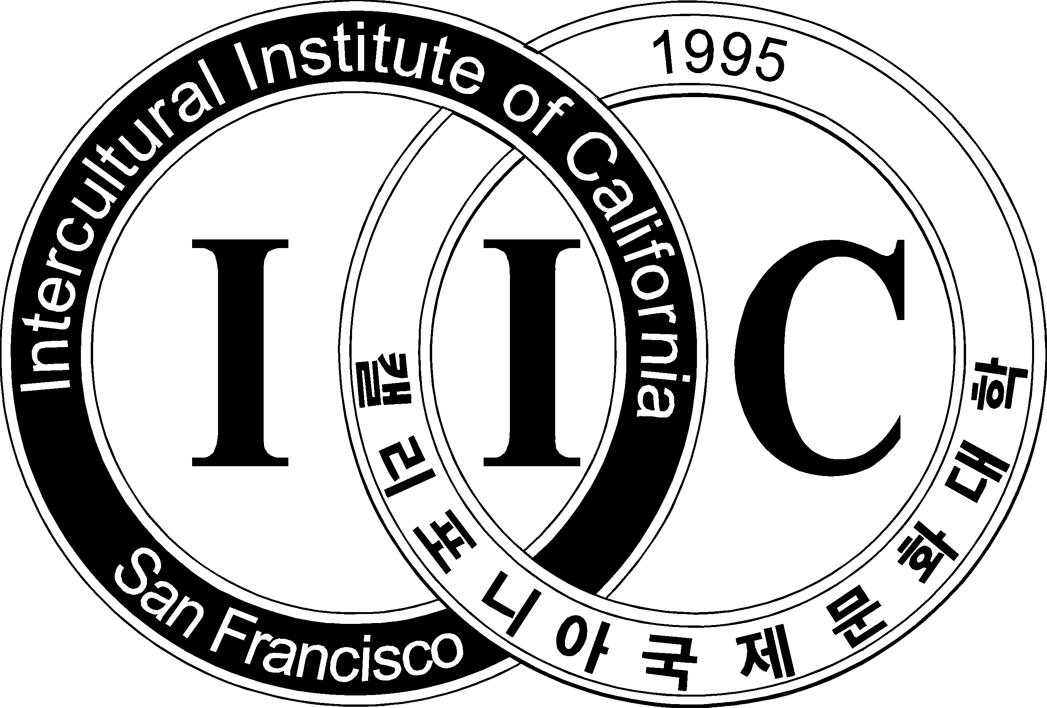
Intercultural Institute of California
1362 Post Street, San Francisco, CA 94109
Tel: (415) 441-1884, Fax: (415) 885-4155
www.iic.edu, info@iic.edu

