Nancy Abelmann
“Reflections on The Intimate University: Korean American Students and the Problem of Segregation”
Monday, October 11, 2010 5:00-6:30 pm. Literature Building Room 155 (deCerteau)
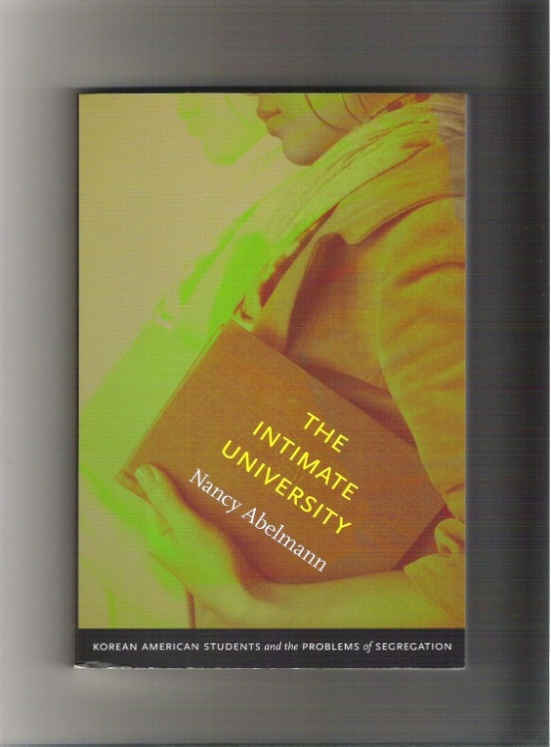
Nancy Abelmann will introduce the primary argument in The Intimate University (Duke University Press, 2009) about the ways in which Korean American students navigated the burden of racial stereotypes, foremost their image as instrumental strivers, as they managed their college lives. For many this meant working hard to appear to be anything but students motivated only be material rewards – an effort that characterized social life both in and beyond the popular largely Korean American student church. Deeply motivated to realize liberal ideals, many Korean American students were dogged by the realities of their often quite uniformly Korean American social lives. Nancy Abelmann will illustrate these arguments with her own favorite ethnographic vignettes from the book. She will also briefly discuss some the responses to the book, particularly from undergraduates. In the second part of the talk, she will turn to new research on the rapid increase of South Korean and PRC citizen undergraduates at the University of Illinois, nearing 10% of the student body, and likely to soon outnumber Asian Americans. Nancy Abelmann will reconsider her arguments in The Intimate University about liberal attachments in the light of the neoliberalization of higher education globally, asking what challenges international undergraduate student poses to our universities and times.
Nancy Abelmann is the inaugural speaker for this year’s Korean Studies Speaker Series, entitled, “Modern (Sub-)Empires and Transnational Korea.” She is Associate Vice Chancellor for Research and the Harry E. Preble Professor of Anthropology, Asian American Studies, East Asian Languages and Cultures, and Gender & Women’s Studies at the University of Illinois at Urbana-Champaign. She co-directs the Ethnography of the University Initiative and served as the director of the Center for East Asian and Pacific Studies from 2005-2008. She has published books on social movements in contemporary South Korea; women and social mobility in post-colonial South Korea; Korean America; and South Korean film. She is a co-editor of forthcoming No Alternative? Experiments in South Korean Education (Berkeley: Global, Area and International Archive, University of California Press, 2011).
The lecture series is sponsored by a grant from the Office of the Dean, the Division of Arts and Humanities and additional support from the Korea-Pacific Program, IR/PS.

