**CALL FOR SUBMISSIONS**

**Journal of Poverty Alleviation and International Development (JPAID)**

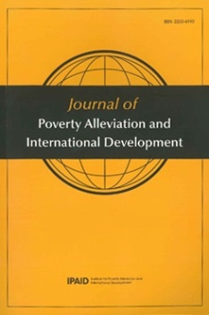

**Aims and Scope**

The Journal of Poverty Alleviation and International Development (JPAID), is the English-language peer reviewed journal of South Korea’s primary university-based center for research on poverty and development, the Institute for Poverty Alleviation and International Development. It is housed within Yonsei University, one of Korea’s leading and most research intensive universities. JPAID is a free, open-access journal dedicated to the timely publication of original, multidisciplinary research related to poverty alleviation and/or development. We particularly encourage submissions examining aspects of Asia’s role in these issues.

South Korea is one of only a handful of countries that have successfully transitioned from low-income to developed country-status since the end of World War II. South Korea is now an important contributor to international development debates and practices, both as a potential model for successful development, and as an OECD-DAC donor, major trading nation and foreign investor. In line with this growing global responsibility, and with funding support from the National Research Foundation of Korea (NRF-2013S1A5B8A01055336), the Institute of Poverty Alleviation and International Development and Yonsei University produce JPAID in order to provide a venue for rigorous scholarship on development issues that is grounded in Korea, yet with a global perspective, and accessible to a diverse international audience.

**Publication information**

JPAID is published twice a year, on June 30 and December 31. Issues are available in print to subscribers, and all articles are free to download through our website: <http://jpaid.yonsei.ac.kr>.

**Submissions**

Submitted articles should be original work not published elsewhere. Manuscripts must be written in English, and ordinarily will be between 6,000 and 9,000 words, including all notes and references. Submissions must include an abstract of no more than 250 words, and all author names, affiliations, and complete contact details.

For full submission guidelines and information about journal policies and procedures, please visit our website <http://jpaid.yonsei.ac.kr> or contact the Managing Editor, Dr. Joel Atkinson, at [jpaid@yonsei.ac.kr](mailto:jpaid@yonsei.ac.kr).

**Annual prizes**

*JPAID Outstanding Publication Prize*

JPAID awards a US$1000 annual prize to the author of an outstanding paper published in the journal during the previous twelve months. A prize of US$500 is awarded to the runner up. The prizes are intended to encourage and recognize excellence in research related to poverty and development. Please see our website for more details.

*JPAID Prize for Early Career Researchers*

JPAID awards a US$500 annual prize in order to recognize the emergence of new researchers with outstanding potential. The prize is awarded to the sole author in the early stages of his or her research career who has published an outstanding paper in the journal during the previous twelve months. The winner must be a PhD or Masters student or within 3 years of completing their degree when the paper was accepted. Please see our website for more details.