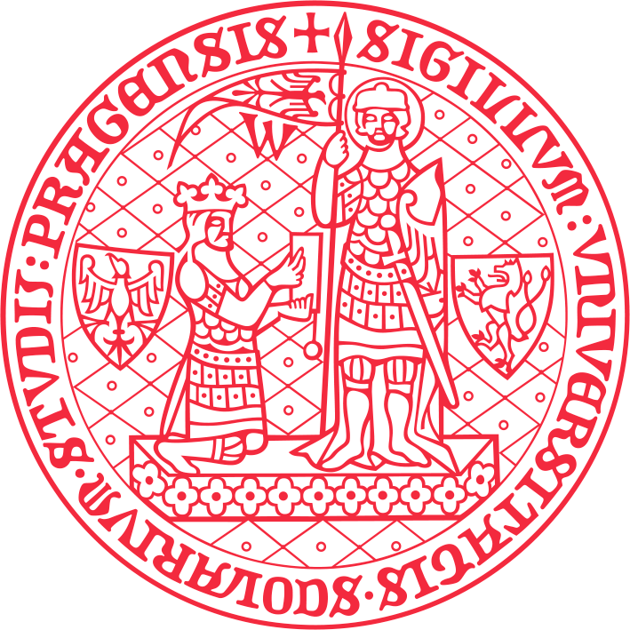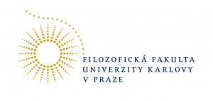

International Conference on Korean Philosophy

Location: Univerzita Karlova v Praze, Karolinum, Ovocný trh 3, 110 00 Praha 1, Císařský sál Karolina, Celetná 20, Zelená posluchárna

Dates: from 26th to 28th June 2014

Organised by: Department of Korean Studies, Charles University in Prague, Faculty of Arts with generous support of Academy of Korean Studies (Core University Program for Korean Studies (CUPKS))
In association with: The Institute of Confucian Philosophy and Culture, Sungkyunkwan University, Seoul

Program of the conference

27th June AM
Císařský sál Karolina

9:15-10:00 Keynote speech by CHOI Young Jin 최영진 (Sungkyunkwan University): 사단칠정논변 미발논변 심설논변의 종합적 연구

10:00-10:40 Doil KIM 김도일 (Sungkyunkwan University): Qian(謙)& Modesty

10:40-11:20 Yun Jin DAN 단윤진 (Sungkyunkwan University): 중용의 도에 관한 주자와 다산 주석의 비교 연구 : 제1장을 중심으로

11:20-11:35 Coffee break

11:35-12:15 XING Liju 邢麗菊 (Fudan University): 주자학에 대한 조선 후기 성리학의 계승과 비판

12:15-12:55 ZHAO Tiantian 赵甜甜 (Sungkyunkwan University): 퇴계와 고봉 사단칠정논변의 쟁점에 대한 재검토

27th June PM

14:00-14:40 Isabelle Sancho (CNRS-EHESS): Fragmentariness, intertextuality, and allusiveness in the Hwadam chip

14:40-15:20 Jin Ju YONG 용진주 (Sungkyunkwan University): 겸재 진경산수의 사상적 성격에 대한 연구

15:20-16:00 Kim Daeyeol (INALCO): Wherein did Confucian literati’s interests lie in Buddhism and Daoism during Chosôn period ? : the case of Pak Sedang (1629~1703)

16:00-16:15 Coffee break

16:15-16:45 Diana Yuksel (University of Bucharest): Literati reading of Liezi during Choson period

16:45-17:25 Andreas Müller-Lee (FU Berlin): Sônggyun'gwan and other knowledge institutions in late Chosôn encyclopedic writings

17:25-18:05 Vladimir Glomb (Charles University in Prague): Discourse on qi in the late Chosôn sôngnihak: the case of Im Sôngju (1711~1788)

28th June AM
Zelená posluchárna
9:30-11:00 Round table: Recent trends and currents in Korean Confucianism Studies

11:00-12:00 Conclusion

