# *Program: (final)*

# 10th Conference of the Nordic Association of Japanese and Korean Studies (NAJAKS)

**August 17-19, 2016**

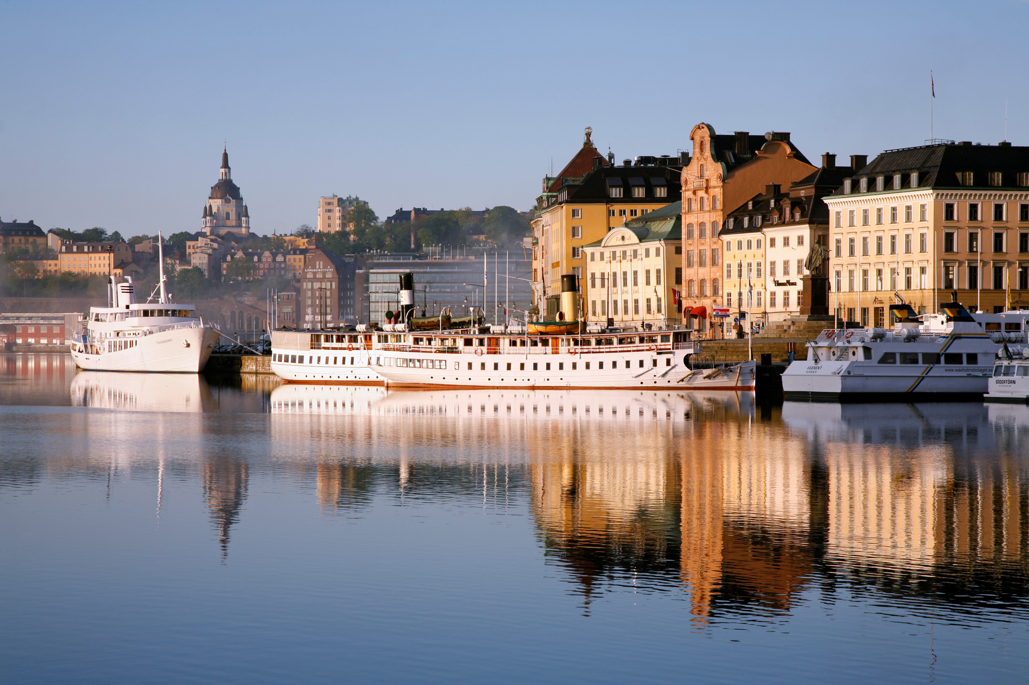

**Venue:**

**Stockholm University**

**Department of Asian, Middle Eastern and Turkish Studies**

**Kräftriket 4 A**

**106 91 Stockholm**

For more information please visit the NAJAKS website: <http://www.najaks.org>

or send an email to the following addresses:

* [Jorunn.Nilsson@su.se](mailto:Jorunn.Nilsson@su.se)
* [Therese.Angenberg@su.se](mailto:Therese.Angenberg@su.se)

## August 17 (Wednesday)

11:30 Registration (Kräftriket 4 A) and Lunch (Restaurant Kräftan)

13:00-13:30 Opening Ceremony (aulan, Kräftriket 4 A)

Welcoming speech:

Jaqueline Berndt, Professor of Japanese language and culture, and Sonja Häussler, Professor of Korean language and culture, Stockholm University

Bengt Novén, Professor and Dean, Faculty of Humanities, Stockholm University

Alberto Tiscornia, Head, Department of Asian, Middle Eastern and Turkish Studies, Stockholm University

His Excellency Nam Gwan-pyo, the Ambassador of the Republic of Korea in the Kingdom of Sweden

His Excellency Jun Yamazaki, the Ambassador of Japan in the Kingdom of Sweden

13:30-14:30 Keynote 1 (aulan, Kräftriket 4 A)

Pak Youngsook (SOAS): Seventeenth-century Japan as seen by the Korean Envoy Hogok Nam Yong-ik (1628-1692)

14.30-14.45 Coffee break

14:45-17:30 Paper sessions: sal B, aulan, sal A

|  |  |  |  |
| --- | --- | --- | --- |
|  | **Crosscultural Encounters** (sal B)  Chair: Gunnar Linder | **Sociology and Cultural Anthropology** (aulan)  Chair: Gabriel Jonsson | **Language** (sal A)  Chair: Mitsuyo Kuwano-Lidén |
| **14:45-15:15** | Taka Oshikiri (University of the West Indies): Consuming Tea at the World’s Columbian Exposition (1893) and the Anglo-Japanese Exh. (1910) | Kim Hyejin (National University of Singapore): The Rise of Urban Farming in South Korea: Resistance to Industrial Food Production? | Giancarla Unser-Schutz (Rissho University Tokyo): On the effect of regional differences in the selection of unique names in Japan |
| **15:15-15:45** | Laura Ipatti (University of Turku): Japanese Perceptions of a “Small Nordic Neutral” and Finland’s Emerging Image Policy in the 1960s– At the Roots of Finland Boom? | Antti Leppänen (Turku University): The Commercial and the Social: Self-Employment amidst Discourses on Social Enterprises in South Korea | Halina Zawiszová (Charles University in Prague): Emotive short response tokens in Japanese young peoples’ conversational interactions |
| **15:45-16:15** | Saara Sorjonen (University of Eastern Finland): Are we talking about Finland when we are talking about Japan? The case of the Finnish translation of Tokutomi Kenjirō's novel *Hototogisu* | Erik Mobrand (SNU): Gender Quotas and Careers of Female Legislators in South Korea | Axel Svahn (Lund University): Non-potential imperatives in Japanese |
| **Coffee break** |  |  |  |
|  | **Linguistics, Language Teaching and Translation** (sal B)  Chair: Park Hyeon-Sook | **History** (aulan)  Chair: Iain Sands | **Literature and historical interpretation** (sal A)  Chair: Kim Eunah |
| **16:30-17:00** | Toshiyuki Sadanobu (Kobe University) and Youngbu Kang (Kyung Hee University): Hesitant word-internal prolongation in Japanese and Korean | Alexandra Lichá (Charles University, Prague): Building colonial Chemulpo: what legacy for Incheon? | Sonja Häussler (Stockholm University): The Perception of the Other in 15th century Korean literature – a Case Study of Kim Sisǔp‘s Poetry |
| **17:00-17:30** | Kim Jeong-young (Helsinki University): What Matters in the L2A of ’-nita’ and ’-yo’? | Jung Byung-sul (SNU): The Early Catholics in Korea and Martyress Yi Suni (1779~1801)’s Letters from Prison | Kim Yeogeun Sue (Chonbuk National University/Oxford University): Too Young to Be Historical |

17:45-18:45 Cultural program (aulan)

Gunnar Jinmei Linder, Niklas Natt och Dag, Iain Sands (Stockholm University)

19:00-21:00 Dinner (Restaurant Kräftan)

## Thu, 18 August 18 (Thursday)

9:00-11:30 Paper sessions: sal B, aulan, sal A

|  |  |  |  |
| --- | --- | --- | --- |
|  | **Contemporary Japanese Society** (sal B)  Chair: Jaqueline Berndt | **Political Science** (aulan)  Chair: Gabriel Jonsson | **The Intellectualization of Foreign Information in 18th Century Chosŏn** (sal A)  Organizer/Chair:  Hur Kyeong Jin  Discussant:  Vladimir Tikhonov |
| **9:00-9:30** | Aike Peter Rots (Oslo University): Forest Lovers, Forest Walls: Tree-Planting, Cultural Nationalism, and Religious Activism in Post-Tsunami Tohoku | Song Eunyoung (Yonsei University): Minjung as Subjects of Dissent and Ideology of the Nation-State under Park Chung-hee Regime] | Park He-min (Yonsei University): 18th Century Europe in the Chosŏn Geographical Imaginary |
| **9:30-10:00** | Kenji Suzuki (Meiji University): Why are young Japanese so pessimistic about the future of their country? – A comparative analysis of seven countries including Japan, Korea and Sweden | Katri Kauhanen (Turku University): Mobilized women and mass dictatorship in the Cold War South Korea | Cui Yinghua (Yonsei University): The Inflow and Intellectualization of Foreign Information Through Early 18th Century Chosŏn “Drifting Records” |
| **10:00-10:30** | Nataša Visočnik (University of Ljubljana): Inclusions of Others into the Japanese society: The Case of Korean Minority in Kyōto | Heike Hermanns (Gyeongsang National University): Local Democracy as a tool of national protest - The use of local referenda by the anti-nuclear movement in South Korea | Cho Young-shim (Yonsei University): The Intellectualization of Chosŏn Information of the Ryukyu |
| **Coffee break** |  |  |  |
|  | **Pre-modern Arts** (sal B)  Chair: Pak Young-sook | **Popular Culture/Music** (aulan)  Chair: Gunnar Linder | **Philosophy, History of Thought and Religion** (sal A)  Chair: Choi Hyaeweol |
| **10:45-11:15** | Mesci Beatrix (ELTE Budapest): Concepts behind the differences of visuality of Buddhist figure paintings in Korean and Japanese art | Stephen Epstein (Victoria University of Wellington): Putting an I into K-Pop and J-Pop: Media Flows, Glocalization and Asian Popular Music | Kim Hongkyung (SUNY Stony Brook): Analysis and synthesis: A comparison between the new interpretations of the Analects by Dazai Shundai in Tokugawa Japan and Chŏng Yak-yong in Chosŏn Korea |
| **11:15-11:45** | Chang Chin-sung (SNU): The Trap of Nationalism: The Case of Kim Hongdo (1745-after 1806) | David Hebert (Bergen University College): Metaphor in musical gestures: Japan’s contributions to the art of conducting | Diana Yuksel (Bucharest University): The Confucian moral duty of (public) service in the 16th century Korea and Japan |

11:45-13:15 Lunch (Restaurant Kräftan)

13:15-14:15 Keynote 2 (aulan)

Reiko Abe Auestad (Oslo University): Affect, Natsume Sōseki and World Literature )

14:30-16:00 Paper sessions: sal B, aulan, sal A

|  |  |  |  |
| --- | --- | --- | --- |
|  | **Language** (sal B)  Chair: Mitsuyo Kuwano-Lidén | **Shinto** (aulan)  Chair: Christina Nygren | **Sociology and Cultural Anthropology** (sal A)  Chair: Sonja Häussler |
| **14:30-15:00** | Mariya Aida Niendorf (Dalarna University): Issues on cross-cultural pragmatics: Swedish learners’ attitudes regarding the learning of Japanese politeness strategies | Ryofu Pussel (Kyoto Bunkyo Junior College): Ritual and well-being: the spectrum of ‘sacred’ in the contemporary Shikoku-88-temple pilgrimage | Choi Hyaeweol (Australian National University): Crossing Lines: Korean women, Christianity, and the impulse to claim new space |
| **15:00-15:30** | Fusae Takasaki Ivarsson (University of Gothenburg): A Study of the L2 Kanji Learning Process: Swedish learners in comparison with Japanese schoolchildren | Elizabeth Kenney (Kansai Gaidai University): Healing Spirits and Bodies at a Shinto Shrine in 16th and 17th Century Japan | Sohn Heejeong (SUNY Stony Brook): Re-visualizing the Missionary Subject at Crossroads. Korean Women and Early Photography: of Religion, Modernity, and New Identity (1880s-1920) |
| **15:30-16:00** | Naoko Hosokawa (University of Oxford): Transforming ‘West’ into ‘East’: Perception of Loan Translation in Contemporary Japan | Ernils Larsson (Uppsala University): Abe Shinzō and the “Shinto Right” in Modern Japan | Jung Ji Young (Ewha University): Rethinking the “Large Family” Thesis of Chosǒn Korea: Postcolonial Critics |

16.00-16.15 Coffee break

16:15-18:15 Paper sessions: sal B, aulan, sal A

|  |  |  |  |
| --- | --- | --- | --- |
|  | **Political Science and International Relations** (sal B)  Chair: Marie Söderberg | **Art or Activism? Representing Korea and Japan in Contemporary Visual Culture** (aulan)  Organizer/Chair:  Jaqueline Berndt | **Korea’s Visions of Future: Tradition, Modernity and Beyond** (sal A)  Organizer/Chair:  Vladimir Tikhonov  Discussant:  Chang Insung |
| **16:15-16:45** | Gabriel Jonsson (Stockholm University): Political space for South Korea in the UN Security Council? | Gunhild Borggren (University of Copenhagen): Production and Reproduction: Visualization of Nationhood in Shimada Yoshiko’s Artworks | Vladimir Tikhonov (Oslo University): Communist Visions for Korea’s Future: the 1920-30s |
| **16:45-17:15** | Lee Sangsu (ISDP): China’s foreign policy towards North Korea | Jaqueline Berndt (Stockholm University): The Manga Show that Never Happened: Revisiting the Controversy over the Manhwa Exhibit at the Angoulême Festival in 2014 | Yi Hyegyung (SNU): Yu Kilchun’s theory of modernization: focusing on comparison with Fukuzawa Yukichi |
| **17:15-17:45** | Bert Edström (ISDP): Onodera Makoto and the Yalta Conference: New light on "the lost Yalta telegram" | Ewa Machotka (Leiden University): The Politics of Ecological Art: Contemporary Art Projects in Japan and Korea | Yang Ilmo (SNU): Assimilation between Confucianism and Western thought: the 1880-1900 in Korea |
| **17:45-18:15** |  |  | Hwang Jung-A(Hallim University): State of Emergency and Modernity: South Korea of the 1970s |

18:30-21:00 Dinner and Cultural Program (Restaurant Kräftan)

Cultural program: Zyka Yosakoi group (Stockholm University student group), K-Pop group

## August 19 (Friday)

9:00-11:30 Paper sessions: sal B, aulan, sal A

|  |  |  |  |
| --- | --- | --- | --- |
|  | **Premodern Japan** (sal B)  Chair: Stina Jelbring | **History Disputes and Collective Memory: Northeast Asian Museums as Keepers of National Narratives** (aulan)  Organizer/Chair:  Mark E. Caprio  Discussants:  Vladimir Tikhonov,  Gabriel Jonsson | **Gender Mediations** (sal A)  Chair: Jaqueline Berndt |
| **9:00-9:30** | Raisa Porrasmaa (University of Helsinki): Crossdressing as a motive for parody in Heian-Kamakura Court Literature | Mark E. Caprio (Rikkyo University): War museums and the National Narrative: Japan and the Republic of Korea | Thorsten Kerp (University of Bonn): Between Coquetry and Gallantry: Masculinity Discourses in the Bunka and Bunsei Eras (1804-1830) |
| **9:30-10:00** | Herbert Jonsson (Högskolan Dalarna): The view of *shasei* in the writings of Kaneko Tōta | Guy Podoler (University of Haifa): The Past under the Roof of the Present: South Korea's Contentious Socio-Political History through Museums | Leena Eerolainen (University of Helsinki): Monstrous masculinities in Japanese (weird) cinema |
| **10:00-10:30** | Catharina Blomberg (Stockholm): The First Account of Japan in Swedish – Olof Eriksson Willman’s Observations in 1651-1652 | Ma Xiaohua (Osaka University of Education): Museum wars: Conflicting memory and history in Sino-Japanese Relations | Jessica Bauwens Sugimoto (Ryukoku University Kyoto): Queering *Black Jack*: A look at how the manga industry adapts to changing reader demographics |
| **Coffee break** |  |  |  |
|  | **Cinema** (aulan)  Chair: Kim Eunah |  | **Cultural politics** (sal A)  Chair: Sonja Häussler |
| **10:45-11:15** | Andrew Jackson (Copenhagen University): Historical text and image in *Spring in My Hometown* |  | Maria Osetrova (Institute of Far Eastern Studies, Moscow): North Korean Cuisine as an Instrument of Public Diplomacy |
| **11:15-11:45** | Chia-ning Chang (University of California at Davis): Yamamoto Satsuo and Postwar Japanese Cinema |  | Guahk Youngah (University of Duisburg-Essen):  The politics and processes of Creating Eco-City in South Korea |

11:45-13:15 Lunch (Restaurant Kräftan)

13:15-14:00 Keynote 3 (aulan)

Johan Nordström (Meiji Gakuin University): Propaganda, Education, and the Empire:

Japan in 1936

14:00-14:30 Naomi Yabe Magnussen + Ane Husstad-Nedberg (University of Oslo Library): East Asia databases (aulan)

14.30-14.45 Coffee break

14:45-15:45 NAJAKS Roundtable (aulan):

Reiko Abe Auestad, Sonja Häussler, David Hebert, Andrew Jackson, Mika Merviö, Dick Stegeverns, Vladimir Tikhonov, Lars Vargö.

15:45-16:00 Closing note (aulan)