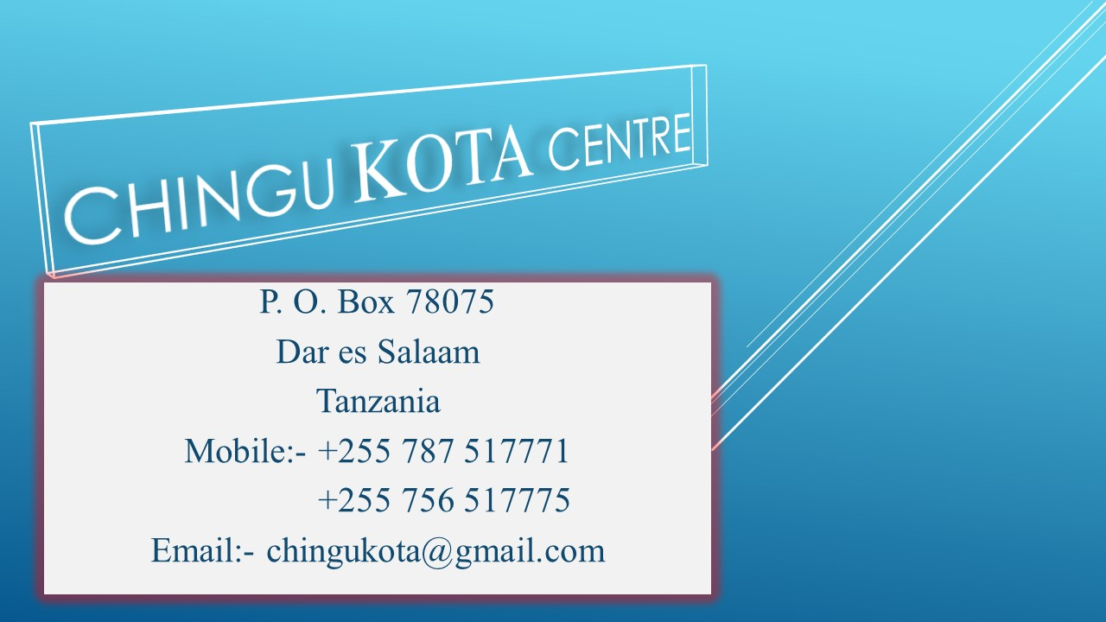

Experience Korea in Tanzania: “Building Connections and Strengthening Ties Through Education”
May 25th – 27th, 2017.
Dar es salaam, Tanzania
The Chingu Kota Centre is a non-political, non-profit scholarly organization dedicated to promoting the study of Korea in Tanzania, and it was registered on October 2016 by the Tanzania Act, under section 12(2) of Act No 24 of 2002 of the non-governmental organization at national and international levels respectively.

For the first time in Africa, The Chingu KOTA Centre and the Academy of Korean Studies invite proposals for presentation at a conference titled: Experience Korea in Tanzania: “Building Connections and Strengthening Ties Through Education”. The Conference will take place at (venue will be announcing soon), in Dar es Salaam, Tanzania. On behalf of the Chingu KOTA Centre organizing committee, we are accepting any topic, the conference covers wide scope of topics:
      - The History of Korean
      - Contemporary discourses on Korean Culture and Korean in academia and beyond
      - Institutional determinants of research on Korean Culture: funding agencies, ethics review boards, globalizing universities
      - Musical tradition in Korea
      - The Korean economic miracle
      - Audiences of Korean culture scholarship in Korea and abroad, their investment, desire and demands
      - Korean Education for foreign Students and abroad
      - Politics of knowledge production in anthropology and area studies
      - Korean government engaged scholarship
      - Gender, religion, race and ethnicity and East Asian Studies; politics of gender and conversion in contemporary South Korean evangelicalism
      - The Transformation of Korean
      - History and Structure of the Korean language
      - History of Korean Art etc.
Note:
The Chingu KOTA Centre organizing committee are Welcoming any University, Colleges, Institutions, Organization if they want to support or organizing this conference together.
The conference aims to introduce a new field of Korean studies as well as Asian Studies by organizing different events/conferences. This conference is an opportunity for participants to meet others in their field conducting similar research, and to gain experience in presenting their work for discussion. We welcome any proposals for papers and panels on all aspects of Asian Studies as well as a comparatives studies, individual papers and panel proposals.
Individual abstract (300 words) and panel proposals (with abstract for each the panelists) should be sent to chingukota@gmail.com by March 25. Successful applicants will be notified by April 25.

Accommodation:
The Chingu KOTA Centre organizing committee will provide airport pick up, meals and three nights’ accommodation (May 25th – 27th) for the presenters only.
This conference is FREE and OPEN to the PUBLIC and all are invited to attend.
For more details see the attachment files

Thank you for your attention
Chingu KOTA Centre
P.o.Box 78075
Dar es Salaam
Tanzania.
Email: chingukota@gmail.com
Mobile: +255 714 111 054
+255 757 676 896

