Call for Paper

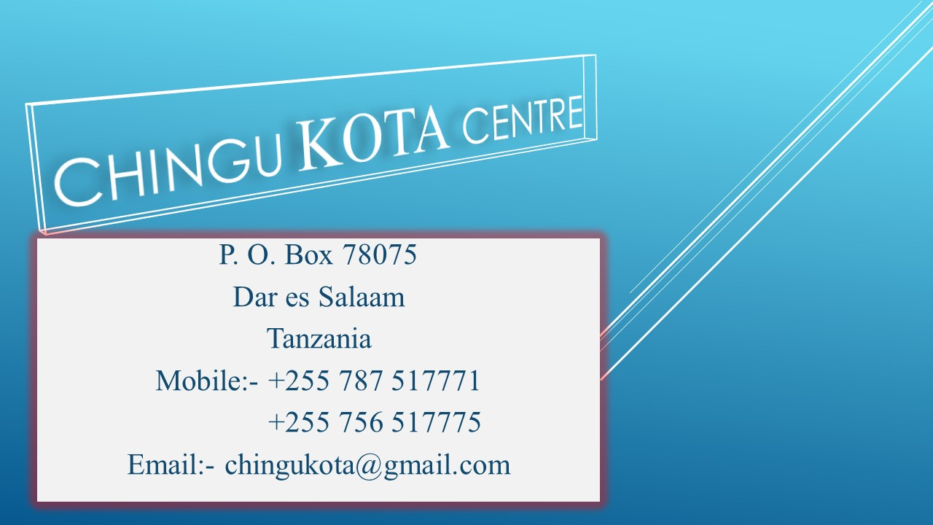

Experience Korea in Tanzania: “Building Connections and Strengthening Ties Through Education”

May 25th – 27th, 2017.

Dar es salaam, Tanzania

For the first time in AFRICA, The Chingu KOTA Centre and the Academy of Korean Studies invite proposals for presentation at a conference titled: **Experience Korea in Tanzania: “Building Connections and Strengthening Ties Through Education”.** The Conference will take place at (venue will be announcing soon), in Dar es Salaam, Tanzania. On behalf of the Chingu KOTA Centre organizing committee, we are accepting any topic, the conference covers wide scope of topics:

Individual abstract (300 words) and panel proposals (with abstract for each the panelists) should be sent to [chingukota@gmail.com](mailto:chingukota@gmail.com) . Successful applicants will be notified by April 25.

**Accommodation**:

The Chingu KOTA Centre organizing committee will provide airport pick up, meals and three nights’ accommodation (May 25th – 27th) for the presenters only.

This conference is FREE and OPEN to the PUBLIC and all are invited to attend.

For more details see the attachment files

Thank you for your attention

Chingu KOTA Centre

P.o.Box 78075

Dar es Salaam

Tanzania.

Email: [chingukota@gmail.com](mailto:chingukota@gmail.com)

Mobile: +255 714 111 054

+255 757 676 896