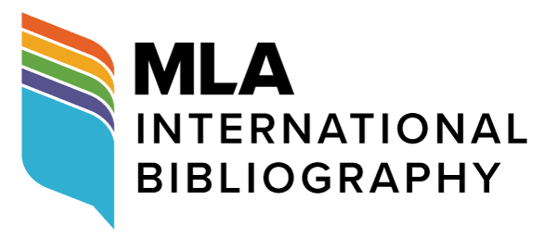

Apply for an MLA Bibliography Fellowship by 1 April 2021

The MLA International Bibliography is accepting applications for three-year field-bibliography fellowships. MLA field bibliographers examine scholarly materials and submit bibliographic and indexing information for citations in the Bibliography. Open to all MLA members, including graduate students, the 2021 fellowships will run from 1 July 2021 to 30 June 2024.

Field bibliographers perform a valuable service for the profession and receive institutional recognition while deepening their knowledge of the field as well as their research skills. The MLA provides materials and training and waives registration fees for fellows attending training sessions at the MLA convention. On completion of the fellowship, fellows receive a $500 stipend and a certificate presented at the convention awards ceremony.

For more information and to submit an application, visit the MLA Bibliography Fellowships webpage. Applications are due 1 April 2021.

