Book Announcement – Azalea: Journal of Korean Literature and Culture, Volume 14
Dear Colleagues:
I am pleased to announce that Azalea: Journal of Korean Literature and Culture, Volume 14, is now available in print (currently in Seoul only) and in eBook (PDF) format.
(The eBook is now live on Project MUSE: https://muse.jhu.edu/issue/45091/print )
ISSN: 1939-6120
ISBN: 978-0-9993148-2-4

Azalea: Journal of Korean Literature & Culture Volume 14 (2021)
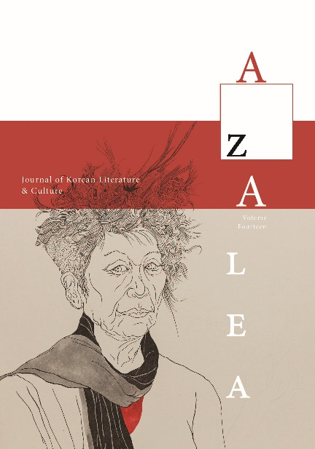

Azalea: Journal of Korean Literature and Culture: Volume Fourteen
Edited by Young-Jun Lee, Professor, Kyung Hee University, South Korea
Azalea: Journal of Korean Literature & Culture promotes Korean literature among English-language readers. Each issue may include works of contemporary Korean writers and poets, as well as essays and book reviews by Korean studies professors in the United States. Azalea introduces to the world new writers as well as promising translators, providing the academic community of Korean studies with well-translated texts for college courses. Writers from around the world also share their experience of Korean literature or culture with wider audiences.
Editor's Note
One of the most important recent shifts in Korean literature is found in gender conflict. This “Special Feature: Gender Trouble in Korean Literature,” guest edited by Lee Hye-ryeong, shows a fundamentally new perspective through six scholars reading Korean literature. Over the past decade, the #MeToo Movement has shaken the world, and Korean society has been no exception, as can be seen in Choi Young-mi’s poem “En,” introduced here with six critical essays. Even before its publication, “En” was the focus of media attention, and it remained a hot topic in Korean society for years due to Choi’s high-profile court battles.
I am pleased to be able to introduce the paintings of Yoon Suk Nam as part of this special feature focusing on gender. A pioneer in feminist art since the late 1980s, she is often called the godmother of Korean feminist art. In particular, the paintings taken from this year's exhibition are portraits of female visionaries during the colonial period. These paintings give us a new understanding of the social roles and complexities navigated by Korean women during the colonial era, reminding us that a great deal of work remains to be done to more fully understand gendered realities emerging from that history.
The “Genre Fiction” feature, guest-edited by Bruce Fulton, also illustrates the change in Korean literature. If 20th-century Korean literature tended toward heaviness, favoring the perspective of the grand narrative through the historical and social particularities of a few individuals, the works gathered here show Korean literature putting down that weight and seeking another direction. The recent emergence of literary works that address speculative fiction, fantasy, horror, and LGBT issues, among others, correspondingly signal fundamental changes in Korean society.
Traditionally, progressive political forces have been supported by the younger generation, but recent years have shown the political orientation of the younger generation to be shifting unpredictably. Changes in women’s consciousness are also not easy to predict, unlike in the past. Current transformations in Korean literature are both the result and cause of social change. Fiction by Jung Young Moon and Hwang Jungeun illuminates the distinctive textures of Korean society in the 21st century: Jung Young Moon captures the chatter pouring out of our present as a snapshot of fragmentary thoughts without plot; Hwang Jungeun introduces hapless young people to a baffling countryside that strongly contrasts with the wealthy, glittery images which often characterize current portrayals of South Korea's city life.
The pandemic is still going on; by the time this phase has concluded, Korean society will be very different from before. We will record and read through literature what has changed—and what has remained the same.
Published by the Korea Institute, Harvard University

