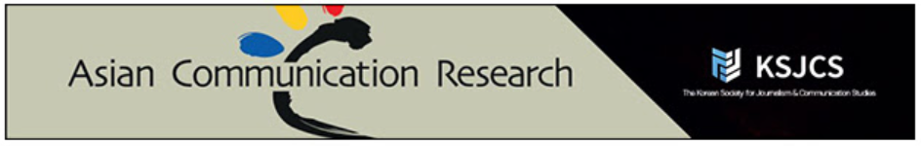

**Why ACR?**

● Free publication

● All papers are DOI enabled

● Included in Korean Citation Index (KCI)

● Open articles in the journal homepage

● Articles presented in meta XML, PDF, PubReader, and ePub

● Quality review and editorial service

**Call for Manuscript Submissions**

We are currently accepting submissions for our second issue of 2022 (Vol. 19 No. 2). *Asian Communication Research* (*ACR*) is a peer-reviewed, international journal of the Korean Society for Journalism and Communication Studies (KSJCS). ACR is registered in the Korean Citation Index (KCI) and published three times a year in April, August, and December. New submissions are always open, but manuscripts submitted by June 10 will be given a priority to undergo peer review after initial editor screening for publication, scheduled to be on August 31, 2022.

● **Submission Deadline**: June 10, 2022

● **Scheduled Date of Publication**: August 31, 2022

● **New Online** **Submission Site**: <https://www.dbpiaone.com/acr/index.do>

To be considered for publication, the submitted manuscripts must adhere to the submission guidelines. Please download and use the manuscript template: <http://acr.comm.or.kr/download/ACR_manuscript_template.docx>

We are also inviting reviews of books on topics relevant to the scope of the journal. Eligible books for review are those published within the last five years and appealing to an international readership. Authors should provide a clear account of the major issues dealt with in the book and critically evaluate the book’s contribution to the field (2,000–3,00 words). Potential book reviewers should contact the book review editor in advance.

If you have any inquiry, please contact:

**Editor‐in‐Chief**

Sungeun Chung (Sungkyunkwan University, Korea, [chseun@skku.edu](mailto:chseun@skku.edu))

**Associate Editors**

Minsun Shim (Inha University, Korea, [mshim@inha.ac.kr](mailto:mshim@inha.ac.kr))

Borae Jin (Joongbu University, Korea, [bjin23@gmail.com](mailto:bjin23@gmail.com))

Kyun Soo Kim (Chonnam National University, Korea, [kimk@jnu.ac.kr](mailto:kimk@jnu.ac.kr))

Christopher J. Carpenter (Western Illinois University, USA, cj-carpenter2@wiu.edu)

**Book Review Editors**

JongHwa Lee (Angelo State University, USA, [jonghwa.lee@angelo.edu](mailto:jonghwa.lee@angelo.edu))

**Associate Managing Editor**

Daeun Jeong (Sungkyunkwan University, Korea, [acr@comm.or.kr](mailto:acr@comm.or.kr))