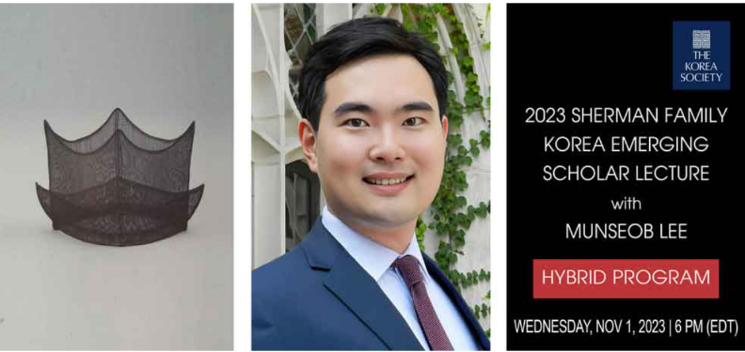The Korea Society is pleased to announce that the winner of the 7th Annual Sherman Family Korea Emerging Scholar Lecture Competition is Dr. **Munseob Lee**, Assistant Professor at the University of California San Diego. Dr. Lee will address ***The Return of Industrial Policy: Lessons from Korea***.  
  
Industrial policy is making a comeback. Signs of government intervention in support of industry are visible not only in China, but in the U.S., Europe, and Asia. Drawing lessons learned from Korea’s experience, Lee provides important insights for today’s policy-makers. A notable case to be discussed is the Korean government's implementation of the heavy and chemical industry drive in 1973. While that policy yielded positive outcomes for the targeted industries, it also resulted in a higher concentration within those sectors.  
  
Lee emphasizes the intricate nature of industrial policy and stresses the need for a thorough evaluation of its costs and benefits before implementation, especially now given the current bipartisan support for substantial bills in the U.S. aimed at revitalizing industrial policy. As one reviewer stated, “At this critical time Lee revisits the effectiveness of Korean industrial policy during a high development phase to glean useful insights for Korea, U.S., and beyond.”

**2023 Sherman Family Korea Emerging Scholar Lecture**  
*The Return of Industrial Policy: Lessons from Korea*  
Munseob Lee

Wednesday, November 1, 2023 | 6 PM (EDT)

|  |
| --- |
| [**Click Here to Receive a Viewing Link**](https://docs.google.com/forms/d/e/1FAIpQLSeEO2Ow1XNhI7kBax5-0VSUE9Rgbj9VRjFEnCdg_U19CjoF9Q/viewform) |

|  |
| --- |
| [**Click Here to Attend in Person**](https://docs.google.com/forms/d/e/1FAIpQLSc3Hlc0t47ewUrEt02sYNOv-ZhHQ7epqmtZxerWjlpjNwEA8A/viewform) |

**The Korea Society**  
350 Madison Avenue, 24th Floor  
New York, NY 10017

The intent of the annual Sherman Family Lecture Award is to grow U.S. thought leadership on Korea for a new generation. The award is presented across disciplines and to emerging thought leaders, from doctoral candidates to junior professors and respective research or non-profit professionals. The award is made possible through the generosity of Mr. and Mrs. Philip Sherman and family. You can view the presentations of former award winners [**here**](https://www.koreasociety.org/policy-and-corporate-programs/item/1392-2020-korea-emerging-scholar-lecture-awardee-announced).