<진실과 화해의 기록, 제주4·3아카이브> 국제심포지엄 안내
International Symposium: Jeju 4·3 Archives - Records of Truth and Reconciliation

Date/Location:
∙ Date: October 14, 2024, 1pm~5pm
∙ Location: PalacePopulaire(Unter den Linden 5, 10117 Berlin)
∙ Topic: Jeju 4·3 Archives - Records of Truth and Reconciliation
∙ Hosted by: Jeju Special Self-Governing Provincial Office, Jeju 4·3 Peace Foundation
∙ Sponsored by: Cultural Heritage Administration, Republic of Korea

Purpose
Jeju 4·3 was a tragic event in modern Korean history, a large-scale massacre that occurred on the beautiful island of Jeju from 1947 to 1954. Approximately one-tenth of Jeju's population perished in this horrific event, which remained a repressed memory, largely unrecognized for a long time. However, after persistent efforts and demands for truth by the survivors and the people of Jeju, a special law was enacted, eventually leading to an official apology from the government.
Today, Jeju is striving to heal the wounds of the past and become a mature community that even embraces those who were perpetrators during that time. These efforts have positioned Jeju 4·3 as an exemplary case in resolving historical issues.
This exhibition and symposium have been organized in London, a hub of global politics, to promote the Jeju 4·3 Archives, <Revealing Truth: Jeju 4·3 Archives>, which have been submitted for UNESCO Memory of the World listing.

Schedule

13:00 – 13:55 |  | 55’ | Exhibition Opening Ceremony
14:00 – 14:10 |  | 10’ | Congratulatory Message
14:10 – 14:20 |  | 10’ | Keynote Speech: Memory in a time of conflict and disinformation
Dan Smith
Director, Stockholm International Peace Research Institute (SIPRI)
14:20 – 14:25 |  | 5’ | Introduction of the Moderator
Prof. Dr. Eun-Jeung Lee
Institute of Korean Studies, Freie Universität Berlin
14:25 – 15:05 |  | 5’ | Presentation
 | 14:25 – 14:45 | 20’ | Jeju 4·3 – Current Situation and Challenges
 |  |  | Jong-min Kim Chairperson, Jeju 4.3 Peace Foundation
 | 14:45 – 15:05 | 20’ | The Jeju 4·3: An Exemplar Microcosm of the Human Records
 |  |  | Prof. Dr. Myung-lim Park Yonsei University
15:05 – 15:25 |  | 20’ | Coffee Break with Jeju Food
15:25 – 16:10 |  | 45’ | Panelists
 | 15:25 – 15:40 | 15’ | On the Complexity and Necessity of Coming to Terms with the Past (Transitional Justice)
 |  |  | Dr. Werner Pfennig Institute of Korean Studies, Freie Universität Berlin
 | 15:40 – 15:55 | 15’ | The role of the memory of Jeju 4·3 for South Korea's identity, foreign policy and international relations
 |  |  | Dr. Florian Pölking Ruhr-University Bochum
 | 15:55 – 16:10 | 15’ | Jeju 4∙3 Archives on Truth and Reconciliation
 |  |  | Prof. Dr. Yoo, Chul-In Professor Emeritus, Jeju National University
16:10 – 17:00 |  | 50’ | Discussion and Q&A

Participants

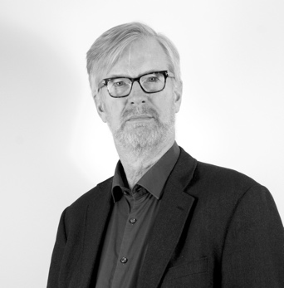
Dan Smith
Director, Stockholm International Peace Research Institute (SIPRI)

Dan Smith is the Director of the Stockholm International Peace Research Institute (SIPRI). Before taking this post in 2015, he had been Director of the International Peace Research Institute, Oslo (1993 – 2001), Secretary General of the London-based peacebuilding NGO, International Alert (2003 – 2015) and Chair of the UN Peacebuilding Fund Advisory Group (2010–2011). He was awarded the Jeju 4·3 Peace Prize in 2021.
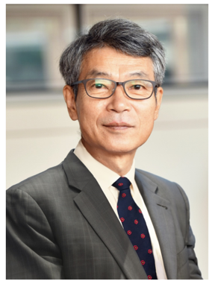
Jong-min Kim Chairperson, Jeju 4·3 Peace Foundation

Starting with the Jeju Newspaper in 1987, and including activities with the 4·3 Reporting Team at Jemin Ilbo, he has spent 36 years focusing on uncovering the truth and investigating the Jeju 4·3, personally meeting with over 7,000 victims and their families. He participated in drafting the Jeju 4·3 Incident Truth Investigation Report, finalized during the Roh Moo-hyun administration in 2003, and is still committed to restoring the honor of the victims.
Prof. Dr. Myung-lim Park Yonsei University

Myung-lim Park teaches at the Interdisciplinary Department of Area Studies, Graduate School, Yonsei University. He teaches there political theory, peace studies, constitutionalism, Korean Studies, and East Asian International Relations. He used to be a visiting professor to EHESS in Paris and to the Free University of Berlin in 2013-2014, and distinguished visiting professor to Jilin University, China from 2014 to 2019, and director of the Kim Dae-jung Presidential Library from 2016-2020.
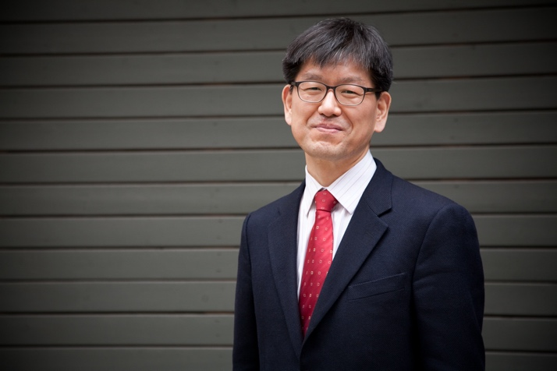
Dr. Werner Pfennig Freie Universität Berlin
Until retirement Dr. Werner Pfennig was Academic Councilor at Department of Political Science, Freie Universität Berlin, and still associated with the Institute of Korean Studies.
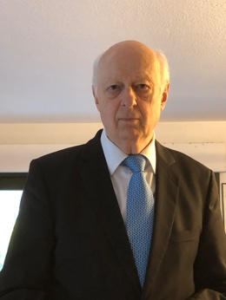
Dr. Florian Pölking Ruhr-University Bochum
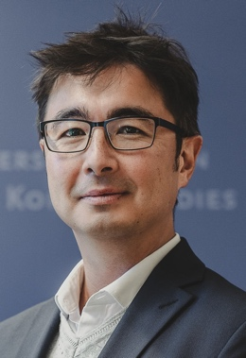
Dr. Florian Poelking is a lecturer and researcher at the Faculty for East Asian Studies at Ruhr-University Bochum. He studied Korean Studies and Sinology (History and Philosophy of China) and obtained his PhD in Korean Studies in 2016. Dr. Poelking employs both historical and contemporary perspectives to examine political, economic, social, and cultural aspects of modern Korea and East Asia using interdisciplinary approaches, such as identity or memory. His current work focuses on South Korea's foreign policy and international political economy, as well as collective memory and national identity in times of multiple global and regional challenges.

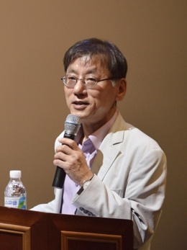
Prof. Dr. Yoo, Chul-In Jeju National University
Chul-In Yoo is a Professor Emeritus of Anthropology at Jeju National University, Korea. He served as the president of several professional societies including the Korean Society for Cultural Anthropology, Korean Oral History Association, and the Society for Jeju Studies. He also worked as the director of Jeju 4·3 Research Institute. He played a key role in preparing the nomination file of the “Culture of Jeju Haenyeo (women divers),” which in 2016 was inscribed on the Representative List of Intangible Cultural Heritage of Humanity by UNESCO. He also played a leading role in submitting the nomination form of the “Revealing Truth: Jeju 4∙3 Archives” for UNESCO Memory of the World International Register in 2023.
<Moderator> Prof. Dr. Eun-Jeung Lee
Institute of Korean Studies, Freie Universität Berlin
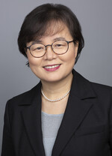
Since 1984, she has been living in Germany, researching political thought, shifts in knowledge, and issues of unification and systemic transition. By introducing a new analytical framework into the history of political thought, she pioneered intercultural research and became the first Asian member elected to the Berlin-Brandenburg Academy of Sciences. In 2008, she founded the Institute of Korean Studies at Freie Universität Berlin, where she currently serves as the head of the Korean Studies Department and the Dean of the Graduate School of East Asian Studies.

Presentation Abstracts

Keynote Speech: Memory in a time of conflict and disinformation
14:10 – 14:20
Dan Smith Director, Stockholm International Peace Research Institute (SIPRI)

Today's global political landscape is marked by increasing insecurity, compounded by the spread of disinformation. Facts play a crucial role in understanding and resolving these issues. Knowledge is required not only about current events—such as advancements in weapons technology, ongoing conflicts, peace efforts, and dialogues—but also about historical events, ensuring that memory is preserved. Remembering tragedies like the Jeju massacre is not just an act of respect for the victims but also a reminder of the importance of truth. Acknowledging that facts matter and that opinions should be grounded in reality is essential to building a more peaceful world. In a culture where facts are valued, peace becomes achievable, and the memory of events like Jeju will not be forgotten.

Jeju 4·3 – Current Situation and Challenges
14:25 – 14:45
Kim Jong-min Chairperson, Jeju 4.3 Peace Foundation

“Jeju 4·3” began on March 1, 1947, when U.S. military government police opened fire, killing six. In response, Jeju residents staged a general strike, demanding accountability, but were met with repression, as Jeju was labelled a "red island." On April 3, 1948, resistance led to widespread massacres and arrests. For decades, silence prevailed, but progress has been made through a special law, truth investigation, a presidential apology, victim compensation, and the nullification of illegal trials, bringing long-overdue justice to the victims.
The Jeju 4·3: An Exemplar Microcosm of the Human Records
14:45 – 15:05
Prof. Myung-lim Park Professor of Area Studies. Director of Kim Dae-jung Presidential Library, Yonsei University

The presentation aims to briefly focus on the origins, process, results, and significance of the Jeju 4·3 Incident from the view point of both the village and the world as well. Also it covers the post-massacre development of truth-revealing movement, petition, reconciliation, and apology at the levels of grassroots and the state, including mutual forgiveness and tolerance between persecutors/police and victims's families. Moreover, it shows and explains the several key raw materials and records directly related to the incident itself and the reconciliation process. Finally it tries to emphasize the value, originality and scarcity of the records of the Jeju 4·3.
On the Complexity and Necessity of Coming to Terms with the Past (Transitional Justice)
15:25 – 15:40
Dr. Werner Pfennig Freie Universität Berlin

"History contains determining factors for the present and the future. This applies particularly to tragedies like 2.28 on Taiwan (1947) and 4·3 on Jeju (1948), which have long-term effects.
Important are the availability and interpretation of documents as well as testimonies of persons involved. It is an extremely difficult task which has to be honest and fair, legally sound, politically wise, and morally just. The challenge is to achieve a sober assessment of the past and durable reconciliation.
There is also an ethical dilemma which plays a significant role especially in East Asian culture and societies. Unearthing and re-interpreting facts can help to identify perpetrators, to exonerate victims, thus bringing relief to their families and descendants, but it can also have the opposite effect of dishonouring one’s ancestors."
The role of the memory of Jeju 4·3 for South Korea's identity, foreign policy and international relations
15:40 – 15:55
Dr. Florian Pölking Lecturer at the Faculty for East Asian Studies at Ruhr-University Bochum

The so-called Jeju April 3rd Incident (henceforth Jeju 4·3) was one of the most brutal events of state violence in South Korea after 1945, yet for various reasons it is little known both nationally and internationally. By acknowledging this and other events of state violence since the 1990s, the collective memory of Jeju 4·3 was to be updated. Nevertheless, there remains a political, social and regional discrepancy in the memory. The dialectic of security and insecurity in the national identity can be understood in close connection with the current efforts for international recognition by UNESCO. This gives Jeju 4·3 a significance that both transcends the national context and has a positive effect on it. At the same time, this initiative has different effects on South Korea's global position and relations.
Jeju 4∙3 Archives on Truth and Reconciliation
15:55 – 16:10
Prof. Chul-In Yoo Professor Emeritus of Anthropology, Jeju National University

Jeju 4·3 Archives consist of the documents about prisoners sentenced by the court martials during Jeju 4·3, testimonies of the victims and the bereaved, civil movements for truth and reconciliation, and the state investigation into truth about Jeju 4·3. These testimonies, revealing the details of intimate histories of the 4·3 violence, promoted truth campaigns. The truth campaigns of Jeju 4·3 are particularly important as they exemplify history from below and the global value of human rights. The processes of reconciliation with the spirit of ‘living together,’ as the means of resolving the history of Jeju 4·3 adopted by civil society including bereaved families, chart a new path for addressing and resolving the historical past of violence.

