<진실과 화해의 기록, 제주4·3아카이브> 국제심포지엄 안내
International Symposium: Jeju 4·3 Archives - Records of Truth and Reconciliation

Date/Location:
∙ Date: October 16, 2024, 1pm~5pm
∙ Location: Brunswick Art Gallery (Brunswick Centre, London WC1N 1AE)
∙ Topic: Jeju 4·3 Archives - Records of Truth and Reconciliation
∙ Hosted by: Jeju Special Self-Governing Provincial Office, Jeju 4·3 Peace Foundation
∙ Sponsored by: Cultural Heritage Administration, Republic of Korea,
SOAS, University of London

Purpose
Jeju 4·3 was a tragic event in modern Korean history, a large-scale massacre that occurred on the beautiful island of Jeju from 1947 to 1954. Approximately one-tenth of Jeju's population perished in this horrific event, which remained a repressed memory, largely unrecognized for a long time. However, after persistent efforts and demands for truth by the survivors and the people of Jeju, a special law was enacted, eventually leading to an official apology from the government.
Today, Jeju is striving to heal the wounds of the past and become a mature community that even embraces those who were perpetrators during that time. These efforts have positioned Jeju 4·3 as an exemplary case in resolving historical issues.
This exhibition and symposium have been organized in London, a hub of global politics, to promote the Jeju 4·3 Archives, <Revealing Truth: Jeju 4·3 Archives>, which have been submitted for UNESCO Memory of the World listing.

Schedule

13:00 – 13:55 |  | 55’ | Exhibition Opening Ceremony
14:00 – 14:10 |  | 10’ | Congratulatory Message for Symposium
14:10 – 14:15 |  | 5’ | Introduction of the Moderator
Pro. Dr. Sojin Lim
University of Central Lancashire

14:15 – 14:55 |  | 40’ | Presentation
 | 14:15 – 14:35 | 20’ | 70 Years of Jeju 4·3
 |  |  | Jong-min Kim Chairperson, Jeju 4.3 Peace Foundation
 | 14:35 – 14:55 | 20’ | The Jeju 4·3: An Exemplar Microcosm of the Human Records
 |  |  | Prof. Myung-lim Park Yonsei University
14:55 – 15:15 |  | 20’ | Coffee Break with Jeju Food
15:15 – 16:15 |  | 60’ | Panelists
 | 15:15 – 15:30 | 15’ | Why Jeju?
 |  |  | Prof. Heonik Kwon Trinity College, University of Cambridge
 | 15:30 – 15:45 | 15’ | The memorialization of the Jeju Uprising and Massacre in global context: truth, justice and anti-communist violence in Korea and Chile
 |  |  | Dr. Owen Miller SOAS
 | 15:45 – 16:00 | 15’ | The Jeju April 3rd Massacre as Universal Heritage: Engaging Memory and Justice through Educational Dark Tourism
 |  |  | Dr. Nikolai Johnsen SOAS 연구원
 | 16:00 – 16:15 | 15’ | Jeju 4∙3 Archives on Truth and Reconciliation
 |  |  | Prof. Yoo, Chul-In Professor Emeritus, Jeju National University
16:15 – 19:00 |  | 45’ | Discussion and Q&A

∙ Simultaneous Translator available (English and Korean)

Participants

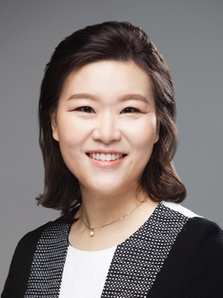
<Moderator> Prof. Sojin Lim University of Central Lancashire

Dr Lim is a Reader (Professor) in Asia Pacific Studies (with special reference to Korea) at the University of Central Lancashire (UCLan). She also works as a Director of the International Institute of Korean Studies. Currently, she conducts a research project on Jeju Haenyeo. Prior to joining UCLan, she worked for aid agencies, including the Korea International Cooperation Agency and the Export-Import Bank of Korea, as a senior research fellow with hands-on field experience. Recently, she was elected as a fellow of the Royal Asiatic Society of Great Britain and Ireland

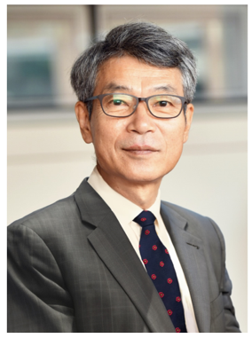
Jong-min Kim Chairperson, Jeju 4·3 Peace Foundation

Starting with the Jeju Newspaper in 1987, and including activities with the 4·3 Reporting Team at Jemin Ilbo, he has spent 36 years focusing on uncovering the truth and investigating the Jeju 4·3, personally meeting with over 7,000 victims and their families. He participated in drafting the Jeju 4·3 Incident Truth Investigation Report, finalized during the Roh Moo-hyun administration in 2003, and is still committed to restoring the honor of the victims.
Prof. Myung-lim Park Yonsei University

Myung-lim Park teaches at the Interdisciplinary Department of Area Studies, Graduate School, Yonsei University. He teaches there political theory, peace studies, constitutionalism, Korean Studies, and East Asian International Relations. He used to be a visiting professor to EHESS in Paris and to the Free University of Berlin in 2013-2014, and distinguished visiting professor to Jilin University, China from 2014 to 2019, and director of the Kim Dae-jung Presidential Library from 2016-2020.
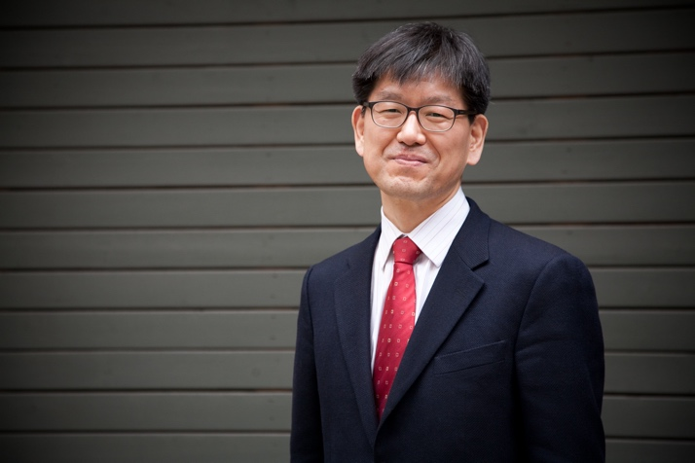
Prof. Heonik Kwon Trinity College, University of Cambridge

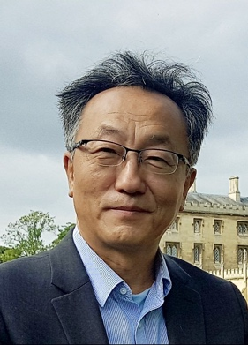
Heonik Kwon is Senior Research Fellow and Professor of Social Anthropology at Trinity College, University of Cambridge. His prizewinning book on the intimate history of the 1950-1953 war in Korea, After the Korean War (2020), draws heavily on the experience of the Jeju islanders.
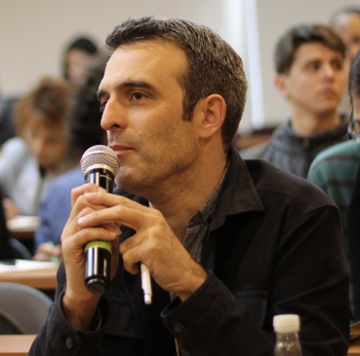
Dr, Owen Miller Lecturer in Korean Studies, SOAS

Owen Miller is Lecturer in Korean Studies in the Department of East Asian Languages and Cultures at SOAS, University of London, where he has taught since 2011. He specialises in the social and economic history of modern Korea and teaches courses including: ‘The Other Korea: North Korea since 1945’, ‘History and Memory in East Asian Cultures’, and ‘The Making of Modern Korea’. His research interests include: the urban and commercial history of Seoul; state capitalism in East Asia; Korean nationalist and Marxist historiographies; and the social history of North Korea. He is currently working on a monograph examining the history of the North Korean industrial city of Hŭngnam from the 1930s to the 1960s.
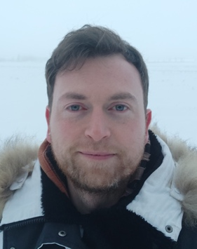
Dr. Nikolai Johnsen British Academy Postdoctoral Fellow, SOAS

Nikolai Johnsen is a scholar of heritage and memory with a focus on the legacies of war and colonialism in East Asia. His doctoral research explored the potential of dark tourism to illuminate marginalised narratives of colonialism in South Korea and Japan. Currently a British Academy Postdoctoral Fellow at SOAS, he is engaged in a research project investigating transnational advocacy networks that aim to bring attention to the heritage of marginalised victims of war and colonialism in East Asia.
Prof. Yoo, Chul-In Professor Emeritus, Jeju National University
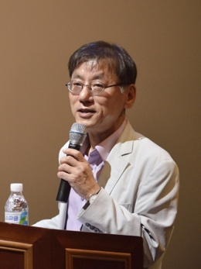
Chul-In Yoo is a Professor Emeritus of Anthropology at Jeju National University, Korea. He served as the president of several professional societies including the Korean Society for Cultural Anthropology, Korean Oral History Association, and the Society for Jeju Studies. He also worked as the director of Jeju 4·3 Research Institute. He played a key role in preparing the nomination file of the “Culture of Jeju Haenyeo (women divers),” which in 2016 was inscribed on the Representative List of Intangible Cultural Heritage of Humanity by UNESCO. He also played a leading role in submitting the nomination form of the “Revealing Truth: Jeju 4∙3 Archives” for UNESCO Memory of the World International Register in 2023

Presentation Abstracts

Jeju 4·3 – Current Situation and Challenges
14:15 – 14:35
Kim Jong-min Chairperson, Jeju 4.3 Peace Foundation

“Jeju 4·3” began on March 1, 1947, when U.S. military government police opened fire, killing six. In response, Jeju residents staged a general strike, demanding accountability, but were met with repression, as Jeju was labelled a "red island." On April 3, 1948, resistance led to widespread massacres and arrests. For decades, silence prevailed, but progress has been made through a special law, truth investigation, a presidential apology, victim compensation, and the nullification of illegal trials, bringing long-overdue justice to the victims.
The Jeju 4·3: An Exemplar Microcosm of the Human Records

14:35 – 14:55
Prof. Myung-lim Park Professor of Area Studies. Director of Kim Dae-jung Presidential Library, Yonsei University

The presentation aims to briefly focus on the origins, process, results, and significance of the Jeju 4·3 Incident from the view point of both the village and the world as well. Also it covers the post-massacre development of truth-revealing movement, petition, reconciliation, and apology at the levels of grassroots and the state, including mutual forgiveness and tolerance between persecutors/police and victims's families. Moreover, it shows and explains the several key raw materials and records directly related to the incident itself and the reconciliation process. Finally it tries to emphasize the value, originality and scarcity of the records of the Jeju 4·3.
Why Jeju?

15:15 – 15:30
Prof. Heonik Kwon Professor of Social Anthropology, Trinity College, University of Cambridge

The people of Jeju underwent an extremely violent time in 1947-1949, even before the destruction of the Korean War engulfed the entire Korean peninsula in 1950-1953. The violence of the era broke apart numerous communities and is in sharp contrast to the extraordinarily peaceful way in which the islanders first expressed their aspirations in March 1947--for genuine decolonisation and against the politics of the Cold War that distorted the decolonising process. In recent years, Jeju has made a commandable achievement in coming to terms with the past and in realising historical justice. In this talk, I will ask how this was possible and why their achievement is relevant for the global civil society and the UNESCO’s Memory of the World initiative.
The memorialization of the Jeju Uprising and Massacre in global context: truth, justice and anti-communist violence in Korea and Chile

15:30 – 15:45
Dr. Owen Miller, Lecturer in Korean Studies in the Department of East Asian Languages and Cultures at SOAS, University of London

My talk draws on the author’s personal experience of visiting both the Jeju 4.3 Peace Park and the Santiago Museo de la Memoria y los Derechos Humanos in 2018. On entering the two museums there are some immediate and striking similarities, including the ‘walls of faces’ that commemorate the dead and missing. Since these visits I have been teaching about Jeju in a course at SOAS called ‘History and Memory in East Asian Cultures’ and I draw students’ attention to the fact that the truth-seeking and memorialization of Jeju 4.3 exists within the broader context of a global ‘movement of movements’ for truth and reconciliation that spans the late 20th and early 21st centuries. In this talk I will move beyond the superficial similarities between these two cases to highlight the deeper significance of the aftermath of anti-communist violence. I will also argue for the importance of the archives themselves, outlasting any commissions and reports. While justice and reconciliation can offer important closure for victims (and perpetrators), for historians and for our future descendants, the pursuit of historical ‘truthfulness’ should remain open. Archives are the most powerful tool we have to continue this process of truth-seeking.
The Jeju April 3rd Massacre as Universal Heritage: Engaging Memory and Justice through Educational Dark Tourism

15:45 – 16:00
Dr. Nikolai Johnsen, British Academy Postdoctoral Fellow, SOAS, University of London

The presentation underscores the global significance of the memory of The Jeju April 3rd Uprising and Massacre and highlights educational dark tourism as a means of promoting universal engagement with this heritage. The Uprising and Massacre hold profound universal relevance, not only as a key event in the onset of the Cold War but also as an instructive example of how transitional justice for mass violations of human rights can be pursued after prolonged periods of state-imposed historical amnesia. Jeju Island has strong potential for increased dark tourism, as research shows that it appeals to general leisure tourists. The potential inscription of the April 3rd Archives in UNESCO’s Memory of the World would further heighten both domestic and international interest in educational dark tours, drawing greater attention to these universally significant but long-suppressed memories.
Jeju 4∙3 Archives on Truth and Reconciliation

16:00 – 16:15
Prof. Chul-In Yoo Professor Emeritus of Anthropology, Jeju National University

Jeju 4·3 Archives consist of the documents about prisoners sentenced by the court martials during Jeju 4·3, testimonies of the victims and the bereaved, civil movements for truth and reconciliation, and the state investigation into truth about Jeju 4·3. These testimonies, revealing the details of intimate histories of the 4·3 violence, promoted truth campaigns. The truth campaigns of Jeju 4·3 are particularly important as they exemplify history from below and the global value of human rights. The processes of reconciliation with the spirit of ‘living together,’ as the means of resolving the history of Jeju 4·3 adopted by civil society including bereaved families, chart a new path for addressing and resolving the historical past of violence.

