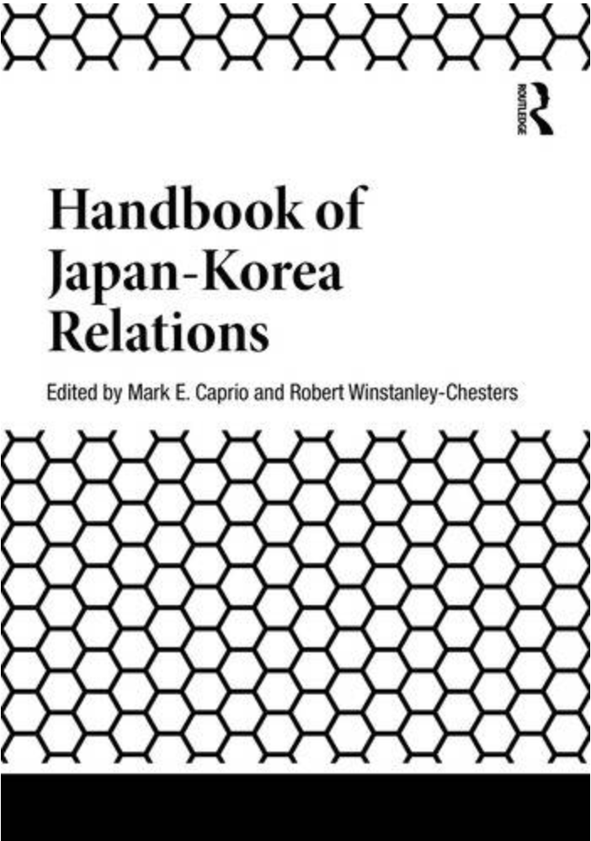
Koreanists may be interested to hear of the very recent publication by Routledge of the Handbook of Japan-Korea Relations, co-edited by Professor Emeritus Mark E. Caprio (Rikkyo University) and Dr Robert Winstanley-Chesters (University of Leeds).
This substantial (28 chapters) handbook volume contains an array of writing on topics pertaining to relations and engagements between Korea and Japan since 1850, including chapters from scholars such as Tessa Morris-Suzuki, Peter Moody, Mark E. Caprio, Igor Saveliev, Markus Bell, Caroline Norma, Patrick Vierthaler, Ágota Duró, Robert Winstanley-Chesters and many more.
Information from Routledge on the volume can be found here: https://www.routledge.com/Handbook-of-Japan-Korea-Relations/Caprio-Winstanley-Chesters/p/book/9781041278856
Summary of Handbook of Japan-Korea Relations from Routledge.com
Analysing almost 200 years of Japan and Korea relations uncovers a relationship that has been both congenial and confrontational. This Handbook examines these relations in this age of modernity by dividing it into four periods: precolonial relations (1850–1905); colonial rule; (1905–1945) postwar/post-liberation (1945–1965); and the modern period (1965–present). With contributions from an international team of experts, the themes of confrontation and cooperation run throughout the book, with chapters focusing on key aspects such as influences from international powers, the era of Japanese colonization, Japan’s relations with the two Koreas and nationalism and historical revisionism.
As a comprehensive overview of diplomatic and cultural conflicts and co-operations between Japan and Korea in the modern era, this Handbook will be a valuable resource to students and scholars of Korean and Japanese history, politics, culture and international relations.
Chapters and Topics
Precolonial Issues
On the Front Line: Establishment and Activities of the Chosŏn Legation in Tokyo
Daria Grishina
Japan’s Colonialist Policy in the Sino-Korean Borderland of Jiandao, 1904–1909
Andrew De Lisle
Colonial Period, 1905–1945
The Influence of the Korean 1919 March First Independence Movement on Japanese Colonial Policy
Mark E. Caprio
Reforms in Japanese-run Colonial Education in Korea, 1919–1925
Andrew Hall
Modernity in a Distorted Mirror: Kim Naesŏng, Edogawa Rampo, and Detective Fiction in Colonial Korea
Jooyeon Rhee
JODK: Musical Transculturation on JODK Radio in Colonial Korea
Kim Jiesun
The History and Character of Language Movements in Colonial Korea: Focusing on the 1920s and 1930s
Takashi Mitsui
Japanese Suiheisha, Korean Hyongpyongsa, and Their Solidarity
Joong-Seop Kim
Myth and Nation-building in Japan and Korea: The Cases of Amaterasu and Tan’gun
David Weiss
Korea, Japan, and the Role of Manchuria in the 1930s: A Prelude to War?
Ku Daeyeol and Mark E. Caprio
Sōshikaimei: The Dichotomy between Assimilation and Differentiation under Japanese Colonial Rule of Korea
Mizuno Naoki
Postwar Period, 1945–1965
A Reconsideration of the Ch’inilp’a (Pro-Japanese Collaborators) Criteria: Formal and Informal Discussions Surrounding the 1947 and 1948 Legislations
AhRan Ellie Bae
Money at the End of Empire: Deportation, Repatriation, Smuggling, and Currency Problems in Occupied Korea and Japan, 1945–1952
Simon James Bytheway
The Dilemma of Delayed Repatriation: Wartime Forced Migration of Koreans to Sakhalin and Their Repatriation to the Republic of Korea
Igor Saveliev
American Occupiers and the Abandonment of Decolonization in Korea and Japan
Matthew R. Augustine
The Hidden History of the 3.1 Infantry Regiment: Zainichi Student Volunteers in the Korean War
Minami Yuki
The 1965 South Korea-Japan Treaty in the Context of Colonialism and the Cold War
Ōta Osamu
Japan and North Korea in the Cold War and Beyond: Remembering the Forgotten Connections
Tessa Morris-Suzuki
Before the Wave, the Ripples: North Korea’s Music Diplomacy with Japan from the 1970s to the 1990s
Peter Moody
Modern Era, 1965 to the Present
Japanese Grassroot Efforts to Assist South Korean Hibakusha Gain Treatment and Other Benefits
Ágota Duró
Letters from South Korea by T.K. Sei: A Transnational Advocacy Network and the Struggle for South Korean Democracy
Younghye Seo Whitney
Skeleton Crews and Sensitive Shores: Cultural Geographies Produced by Unwanted North Korean Bodies during the Ghost Ships Phenomenon, 2011–2020
Robert Winstanley-Chesters
Women in the Post-1965 Japan-South Korea Diplomatic Relationship
Caroline Norma
Regional Influences and Unique Trajectories Within the Hybrid Chosŏn School Network in Japan
Susan Menadue-Chun
Echoes of the Famine: The Resettlement of North Koreans in Japan
Markus Bell
The Right-wing Backlash and Historical Revisionism: Parallels and Differences in Japan and South Korea
Patrick Vierthaler
Bones to Pick: Nationalism Beyond the Grave
Jackie J. Kim-Wachutka
The Post-national Cinema by Sai Yoichi (Choi Yang-il): The Zainichi Family Chronicles, All Under the Moon (1993) and Blood and Bones (2004)
Hyangjin Lee

